Ethnicity - National
The 2011 Census shows that 87% of people in the UK are White, and 13% belong to a Black, Asian, Mixed or Other ethnic group.
According to the Office for National Statistics (ONS) based on population survey figures from 2019, people from ethnic minority backgrounds make up 14.4% of the United Kingdom (16.1% for England, 5.9% for Wales, 5.4% for Scotland and 2.2% for Northern Ireland)

The chart below shows that South Asian ethnic groups combined had the highest percentage of minority ethnic group born in the UK in 2011. Polish and African groups combined form the highest Non-UK born groups.

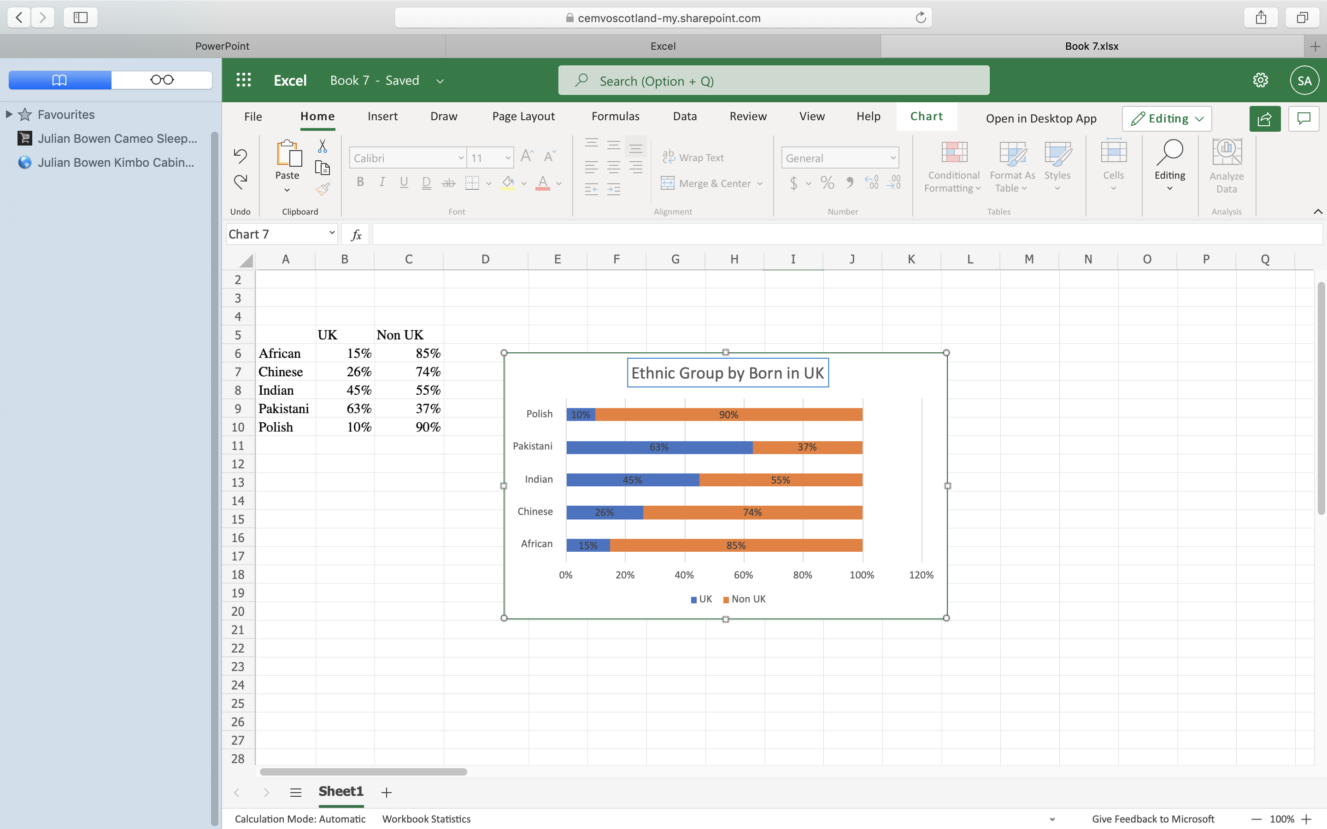

Scotland

The 2011 Scottish Census revealed that Scotland became more ethnically diverse from 2001 to 2011, with the non-white minority ethnic population doubling from 2% to 4% of the total 23 population, or 210,996 people.

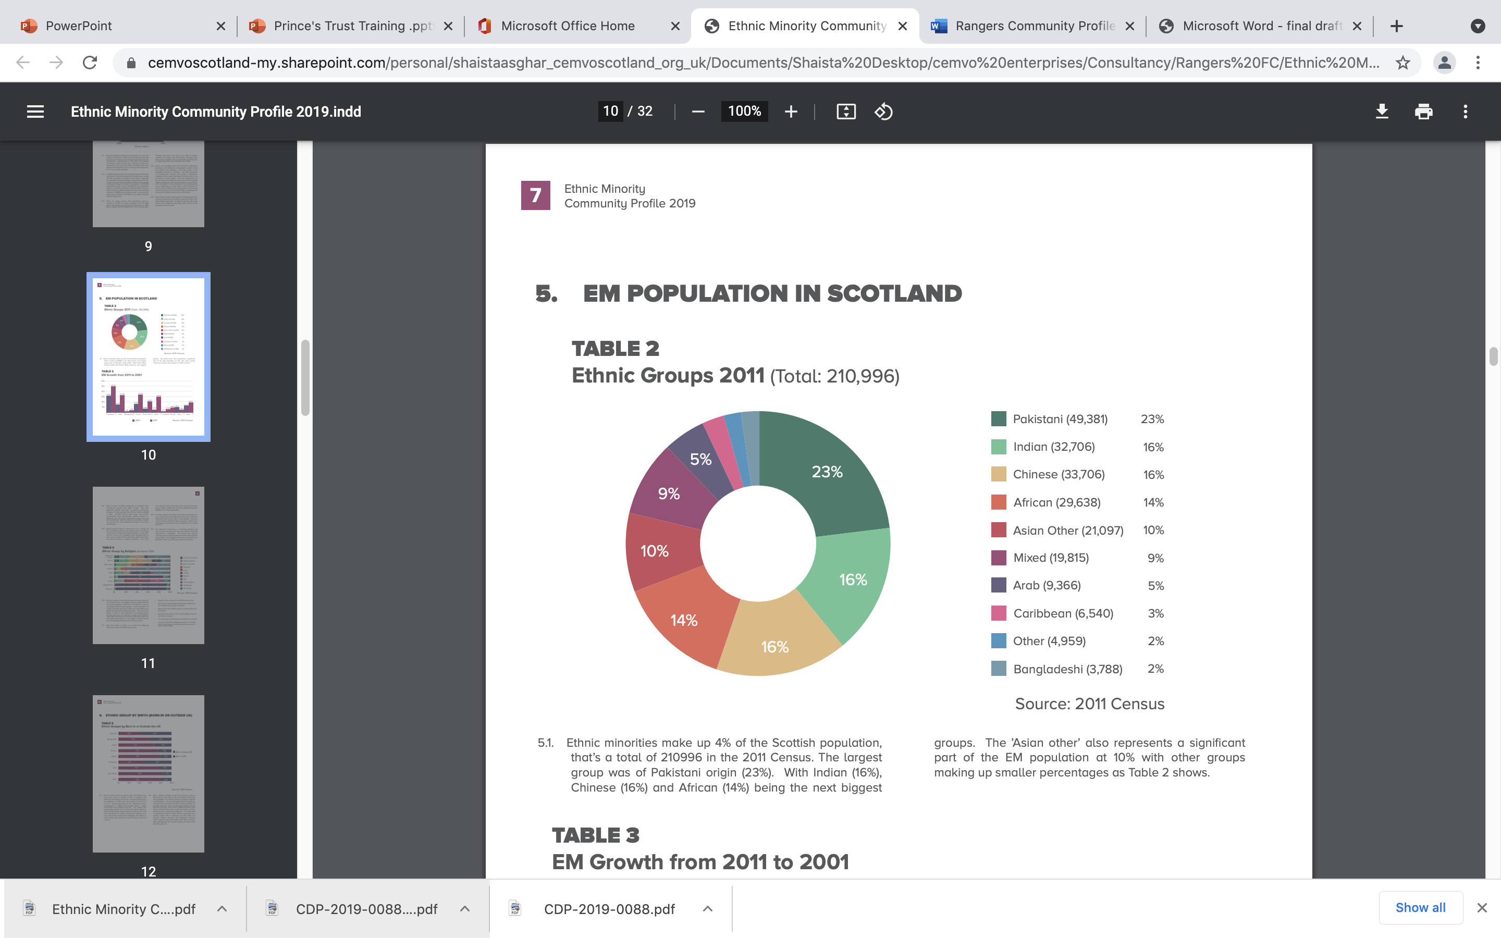

People of Pakistani origin (49,381) were the largest BME group, making up almost a quarter (23.4%) of the BME population. This was followed by those of Chinese origin (33,706) at 15.97%, Indian origin (32,706) at 15.5%, African origin (29,638) at 14%, the other Asian group (21,097) at 10% and those from mixed or multiple groups (19,815) at 9.39%:

Ethnicity -Local

Renfrewshire

Althogh figures are limited to the Census 2011 some key facts on Renfreshire’s minority population are:
- Overseas students and refugee communities make up part of its demographic profile
- According to the 2011 Census – 174 908 people lived in Renfrewshire
- In 2019 the National Records of Scotland estimated 179 100 were living in Renfrewshire
- Predicted population increase to 182 256 by 2028
- In 2018-19 Renfrewshire had the 5th highest level of migration

Renfrewshire has a large proportion of people of white origin compared with people of another ethnic background. This is highlighted in the chart below with over 96% of the Renfrewshire population categorised as white.

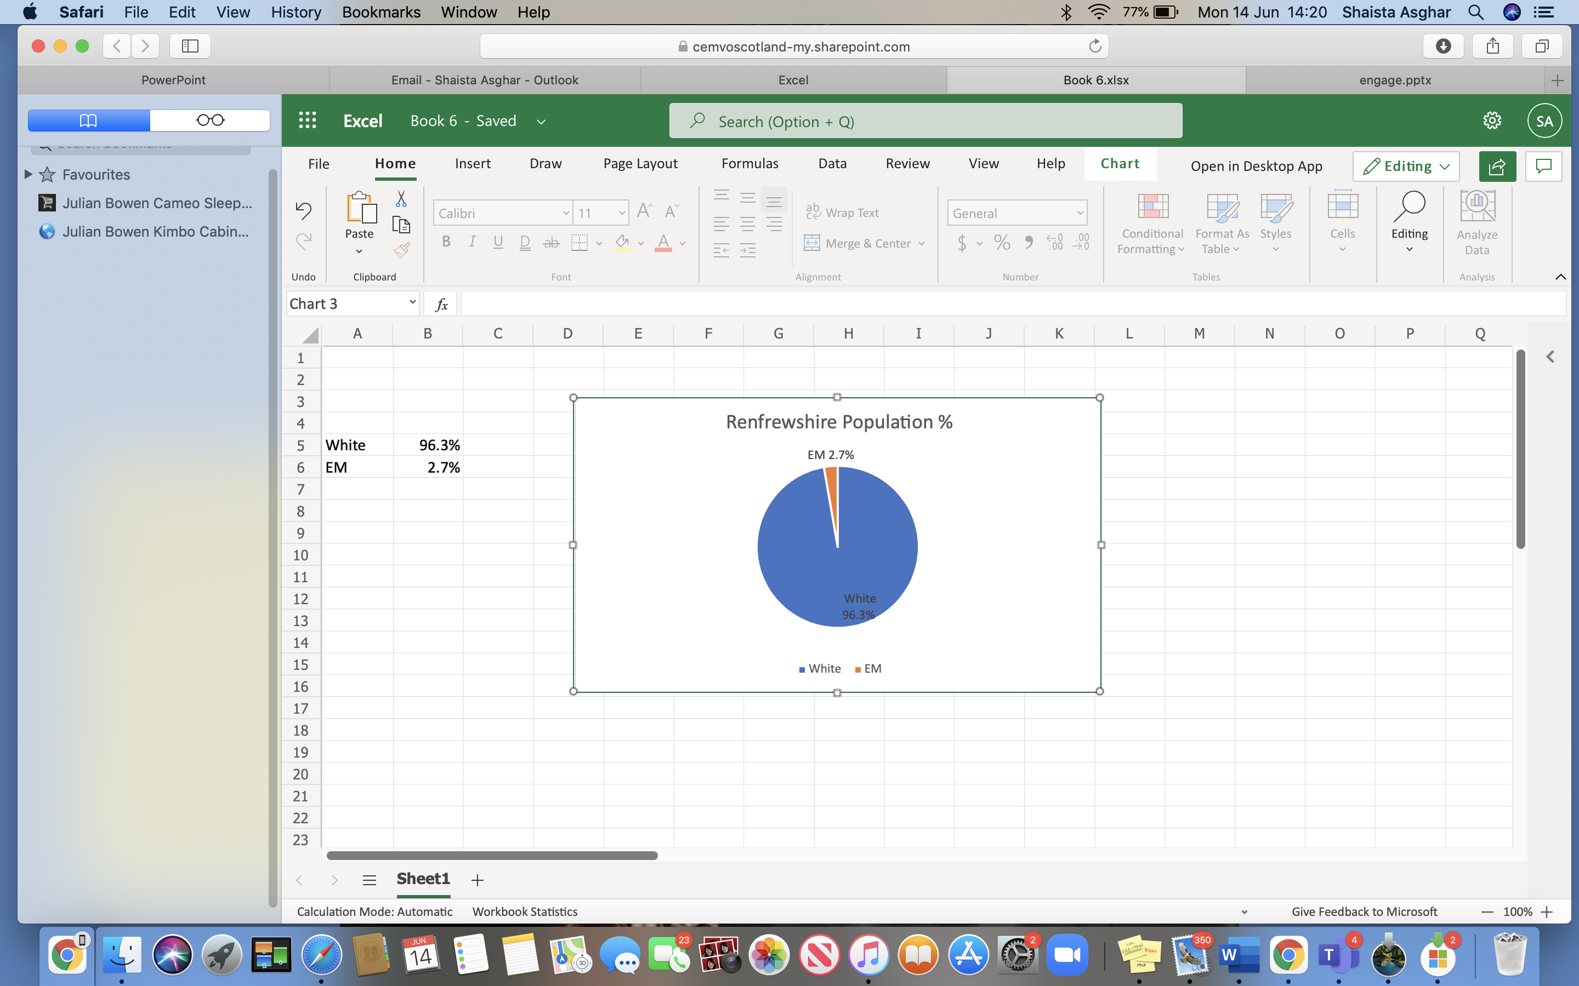

The charts below shows that South Asian and African Caribbean ethnic groups as the largest ethnic groups within Renfrewshire.

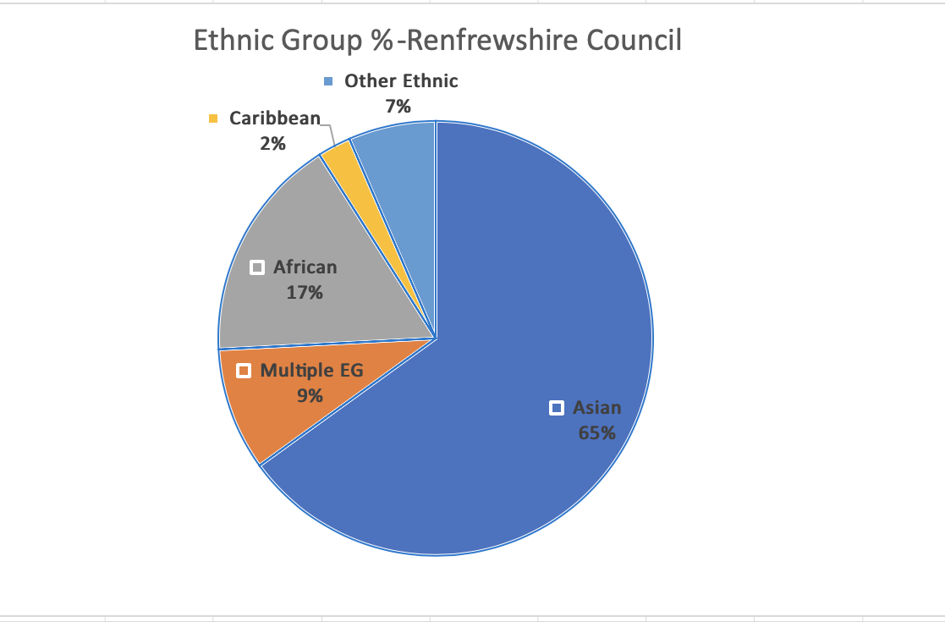

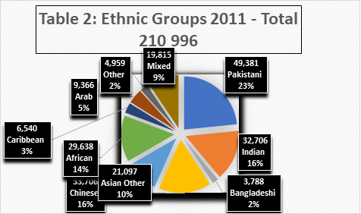

Check for more updates from the 2022 Census

For more information:

RenfLocalAuthorityProfile.pdf (renfrewshire.gov.uk)
Ethnicity | Scotland's Census (scotlandscensus.gov.uk)
The_changing_ethnic_profiles_of_Glasgow_and_Scotland.pdf (gcph.co.uk)

Ethnicity | Scotland's Census (scotlandscensus.gov.uk)

Ethnicity facts and figures – GOV.UK (ethnicity-facts-fig0ures.service.gov.uk)

2011 Census - Office for National Statistics (ons.gov.uk)

